Problem Statement:

Perform and explain the code flow and the associated result for the below tasks. Candidates should

create and use their own employee dataset for the same. Share the screenshot of the commands used

and its associated result.

● Transfer data between Mysql and HDFS (Import and Export) using Sqoop.

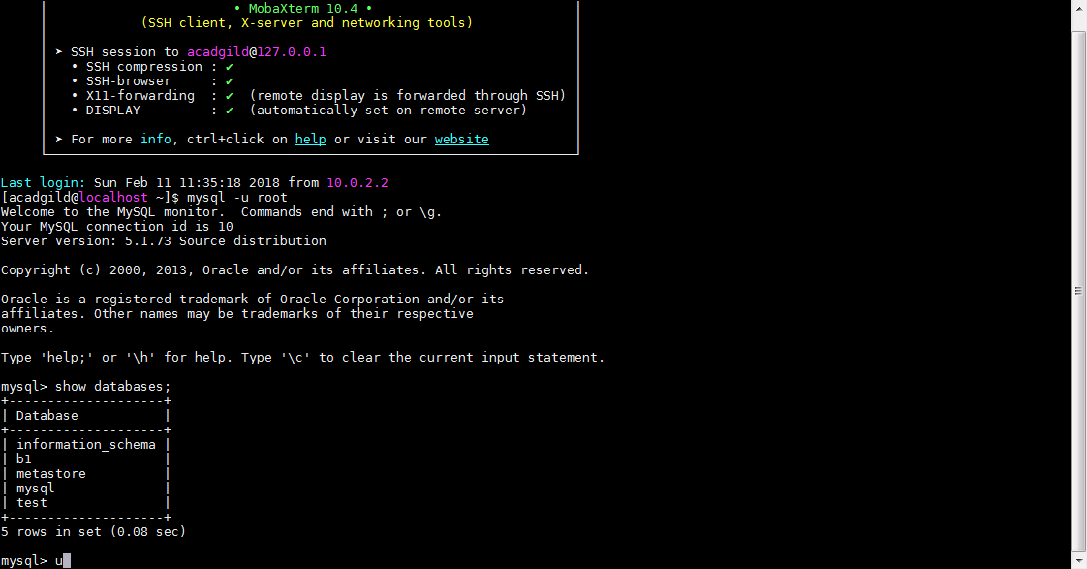

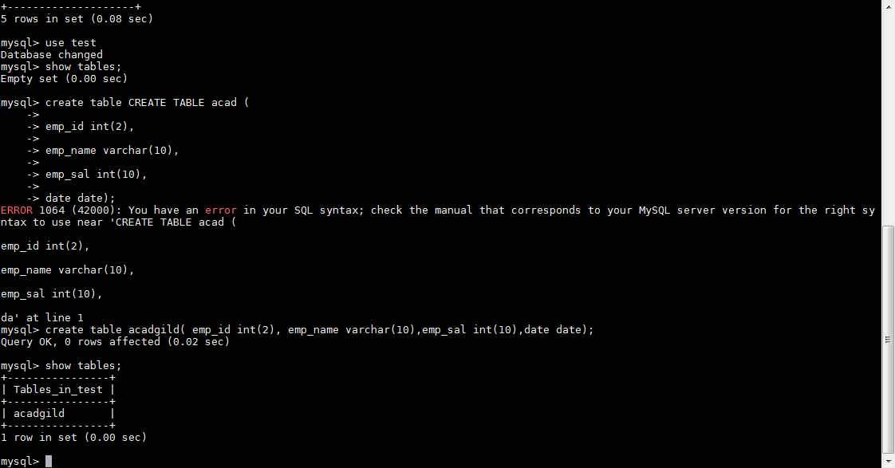

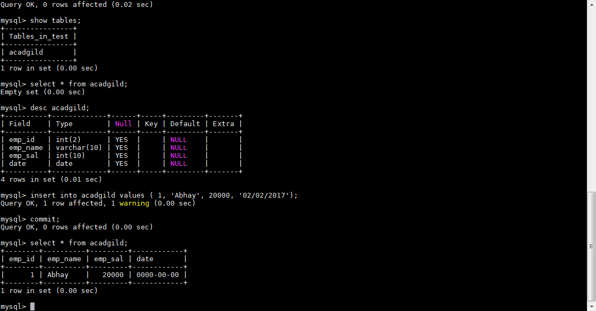

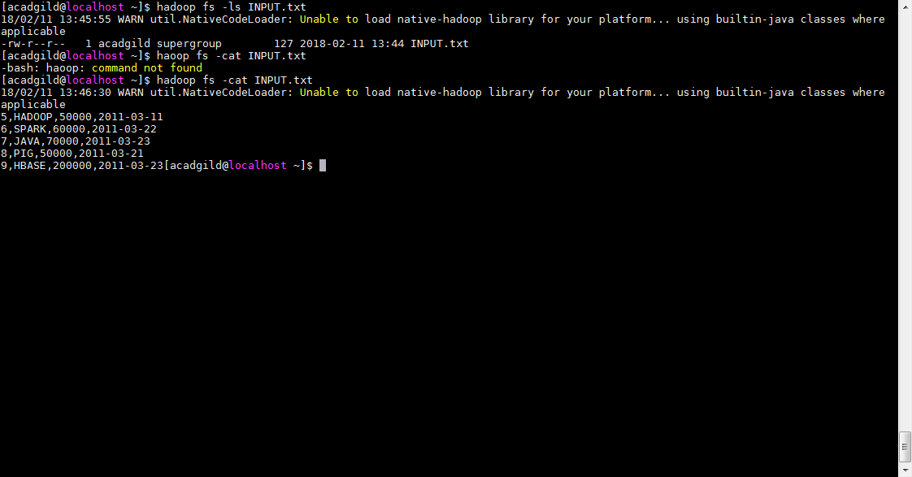

**Export from HDFS command**

**sqoop export -m 1 --connect jdbc:mysql://localhost/test --username root --table acadgild --export-dir /user/acadgild/hadoop/INPUT.TXT**

**screen shot after sqoop export command execution**

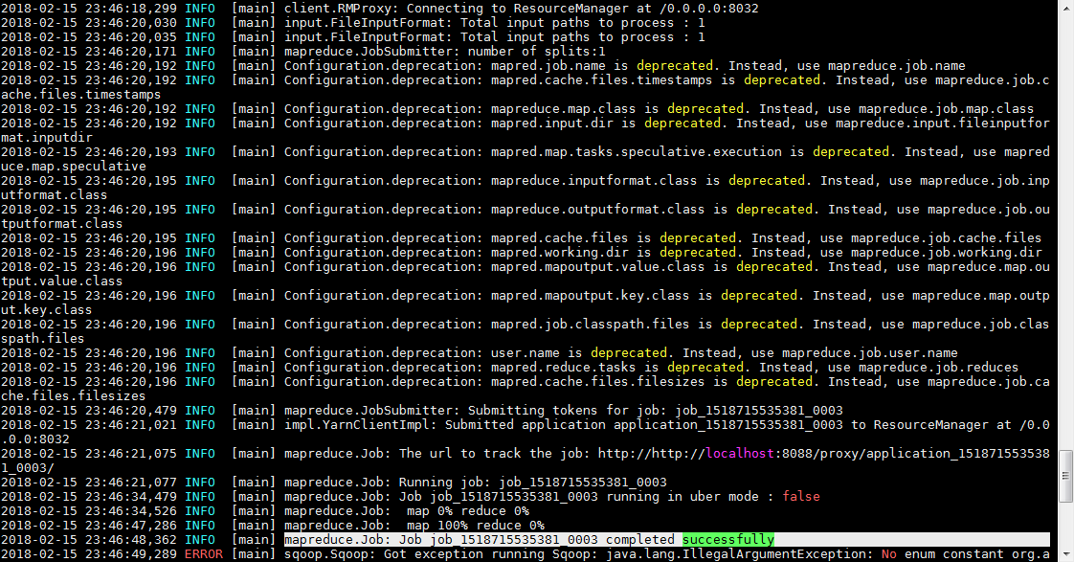

**Data inserted into acadgild table**

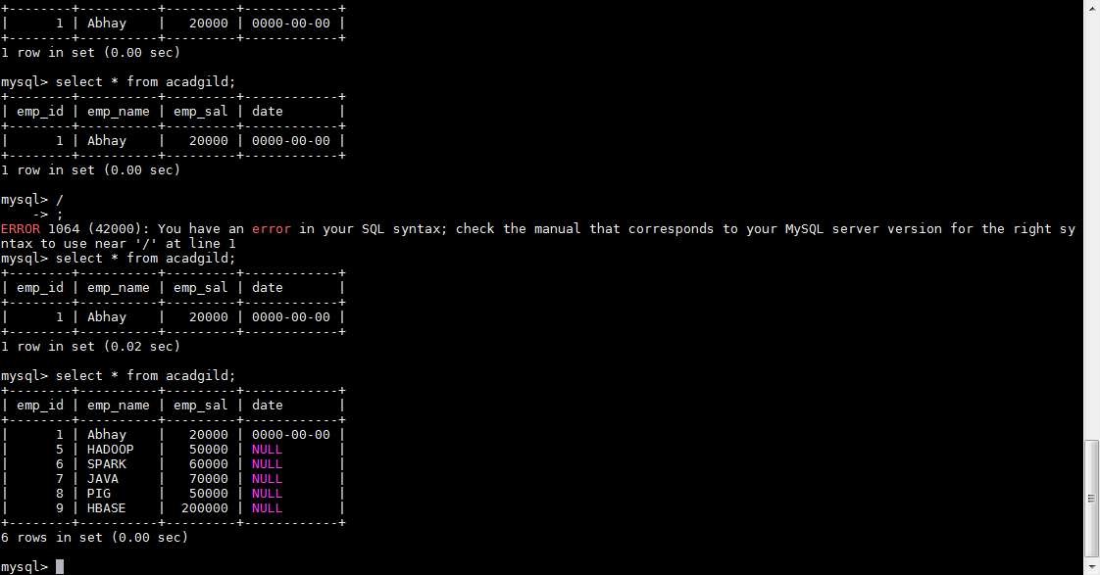

**Import to HDFS from mysql**

**Command :**

**sqoop import --connect jdbc:mysql://localhost/test --username root --table acadgild --m 1**

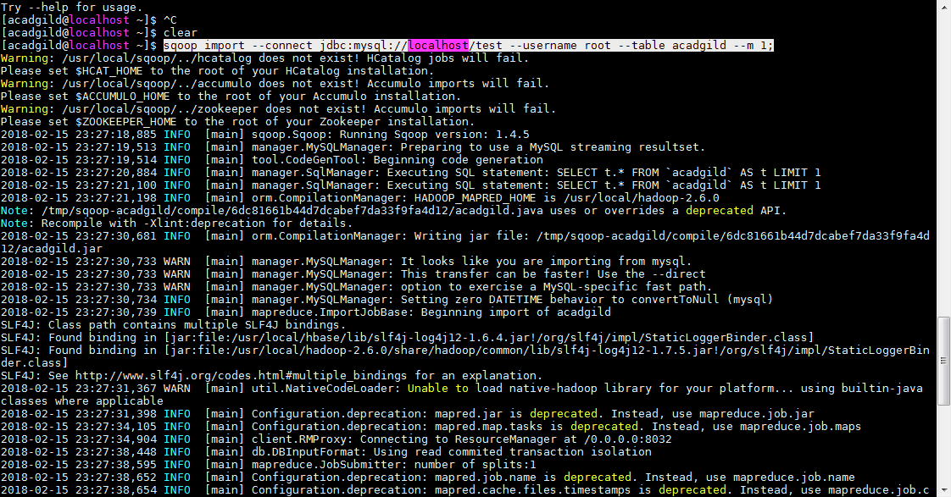

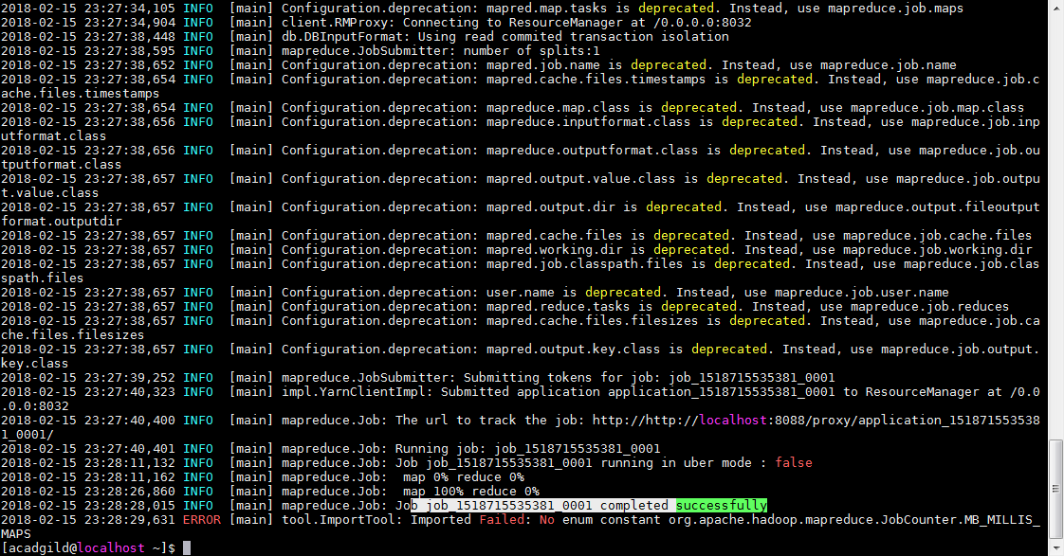

File is created in below location



**Displayed content of files**



● Transfer data between Mysql and Hive (import and Export only selected columns) using Sqoop.

**A Sqoop command is used to transfer selected columns from MySQL to Hive.**

**Command**

**sqoop import --connect jdbc:mysql://localhost/test --username root --split-by EmpId --columns EmpId,EmpName,City --table Company1 --target-dir /myhive --hive-import --create-hive-table --hive-table default.Company1Hive -m 1**

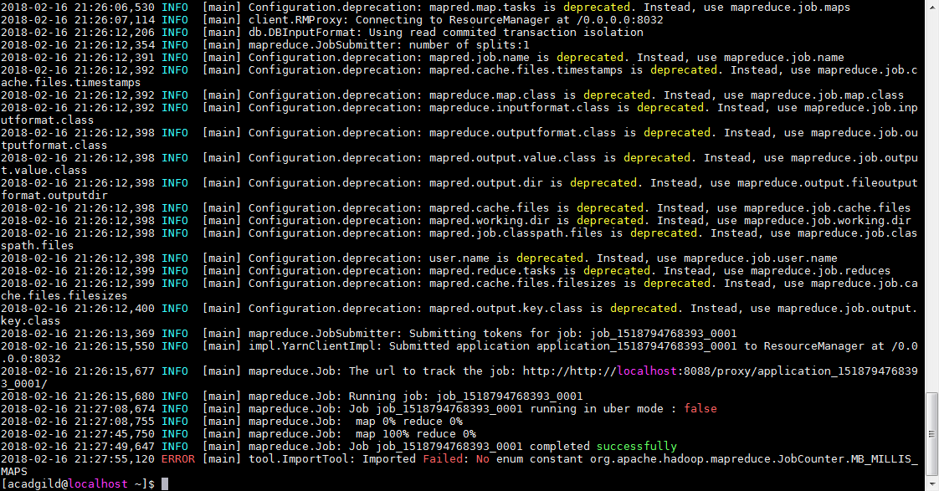

**Transfered data to hive**

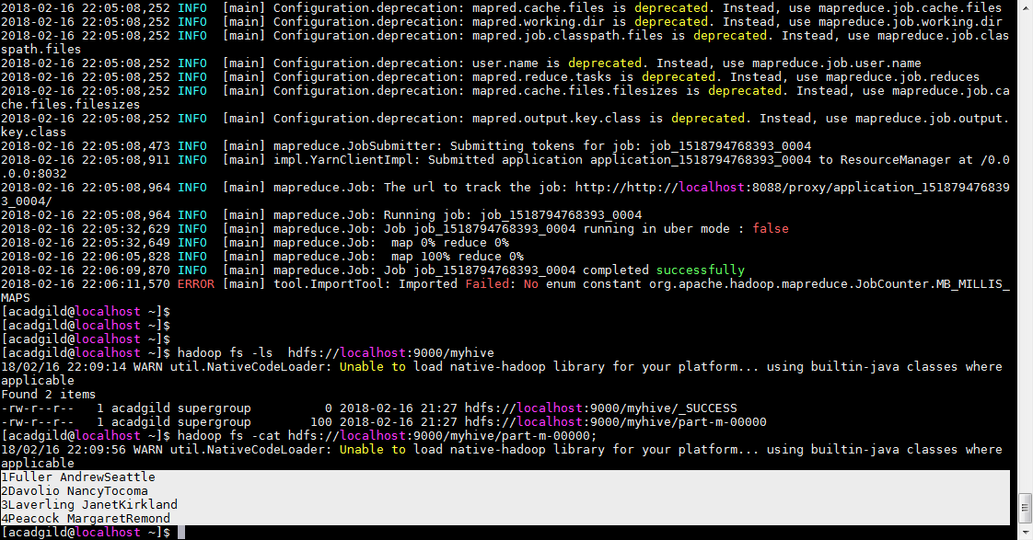

**II. Export command for transferring the selected columns from Hive to MySQL.**

**No data in table Company2 before command execution**

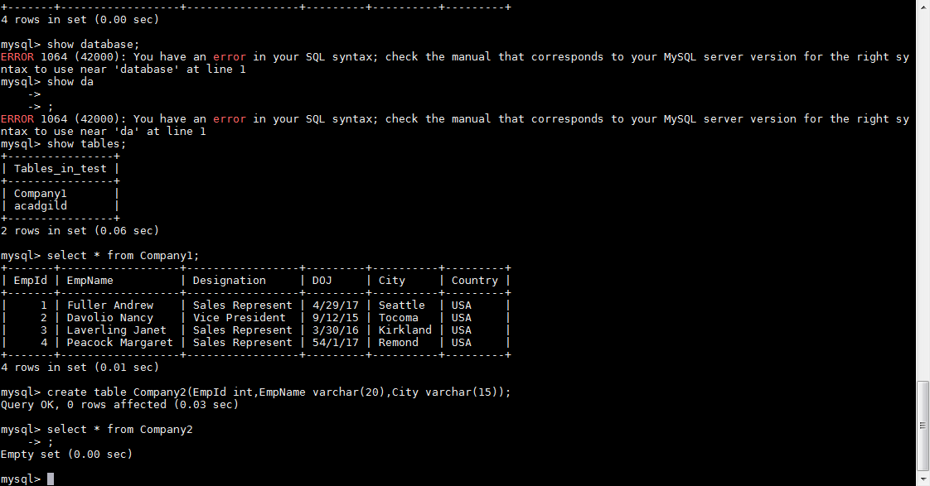

sqoop export --connect jdbc:mysql://localhost/test --username root -–columns EmpId,EmpName,City -–table Company2 -–export-dir /user/hive/warehouse/company2hive –-input-fields-terminated-by ‘\001’ -m 1